- Get the section data from (Patient) Tab and add a section of section report in ( Patient profile) Tab
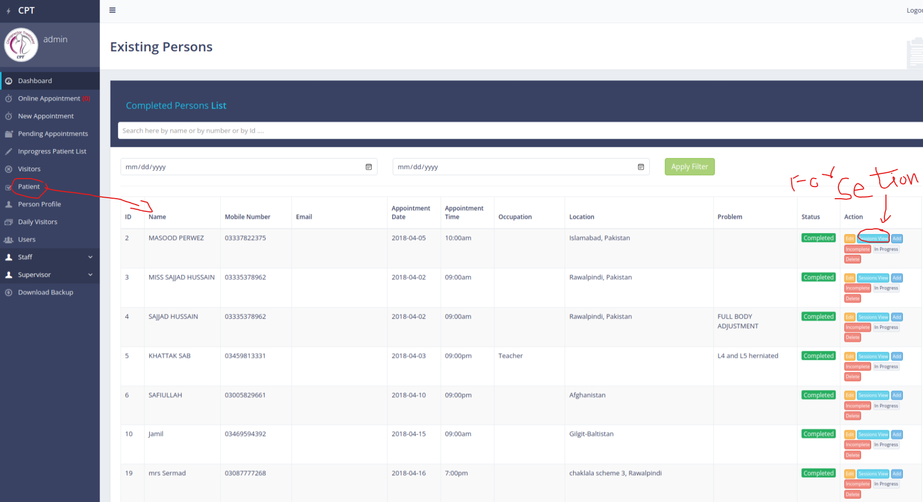

- the Report will be generated in portrait A4 size.

